**How to use QListWidget - An Example**

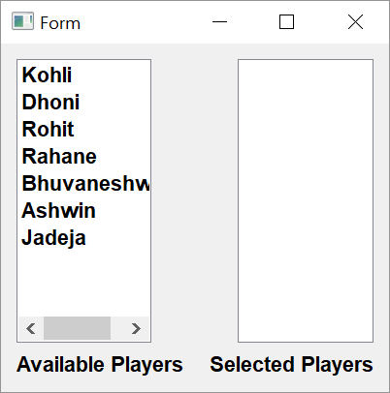

**Step 1**

**Setting up the form**

1. In the example two listwidgets are placed in a horizontal layout. First one, list1 being its name is populated at design time (exactly like QComboBox). The list2 object is empty to begin with.

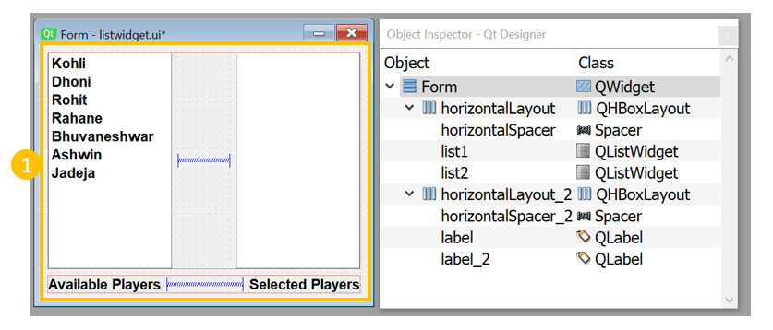

**Step 2**

**Event Handling**

The idea is to select an item in one list, remove the selected item from it and add in other list. For this purpose we use itemDoubleClicked signal emitted by QListWidget widget and connect it to event handler methods.

1. Add following methods in Ui_Form class   
   *def removelist1(self, item):   
   self.list1.takeItem(self.list1.row(item))  
   self.list2.addItem(item.text())  
     
   def removelist2(self, item):  
   self.list2.takeItem(self.list2.row(item))  
   self.list1.addItem(item.text())*

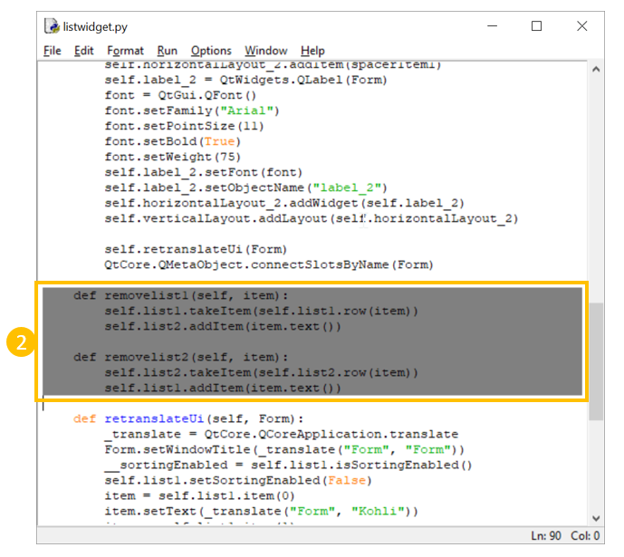

1. These two methods are used as event handlers for itemDoubleClicked signal of list1 and list2 objects respectively.   
   *self.list1.itemDoubleClicked.connect(self.removelist1)  
   self.list2.itemDoubleClicked.connect(self.removelist2)*

The QListWidgetItem on which double click event is performed, is sent as argument to these method. Its text() method retrieves the string from the selected item. The removelist1() method removes selected item from list1 and adds it to list2. Similarly removelist2() method removes selected item from list2 and adds it to list1

